MONDAY: Let’s think about this weekend!
Something good that happened this weekend was:
I consider this a good thing because:
Another good thing that happened this weekend was:
I consider this a good thing because:
One more good thing that happened this weekend was:
I consider this a good thing because:

Wednesday: Let’s think about the whole year!
Something good that I did for MYSELF this year was when:

I consider this a good thing because:

I consider this a good thing because:

Something good that I did for someone else this year was when:
I consider this a good thing because:
Something good that happened to me this year was when:
RANDOM POSITIVE BOX
You may draw or write anything you want in this box but it MUST be POSITIVE! =)
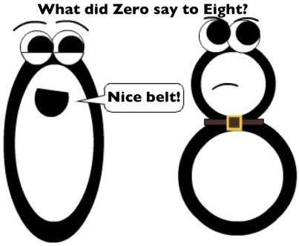

Thursday: Let’s think about the month!
Who have you been the nicest to this year?
What are 3 examples of nice things you have done for this person?
1:
2:
3:
Why have you been so nice to this person this year?
Friday: You survived the WEEK!!!! Yay!!! Let’s review the good things that happened this week
Something good that happened this week was when:
I consider othis a good thing because:
Another good thing that happened this week was when:
I consider this a good thing because:
One more good thing that happened this week was when:
I consider this a good thing because:

